Brand Takeover

A brand takeover is designed to give your business a chance to showcase what you do and how you do it.
The idea is to offer followers knowledge about your brand and your product(s) using a series of questions and answers.
This usually works best if the business provides a giveaway with the topic.
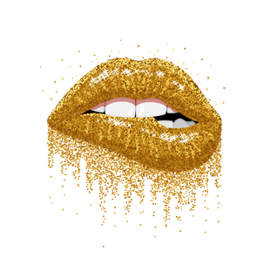
Topics usually reach between 75,000 and 534,000 people based on Facebook Insights.
PLEASE SUBMIT YOUR FORM TO
MARYODONNELLBEAUTY@GMAIL.COM
COMPANY NAME | …
CONTACT NAME
CONTACT NUMBER
EMAIL ADDRESS
ONLINE PLATFORM(S) FACEBOOK
TWITTER
INSTAGRAM
WEBSITE
OTHER
COMPANY BIO

TOPIC QUESTIONS [ONLY FILL ALL 4 IF ELEVANT]
Q1
A1

Q2
A2

Q3
A3

Q4
A4

OTHER INFO
IF APPLICABLE

